**Where to open a Greek restaurant in New York?**

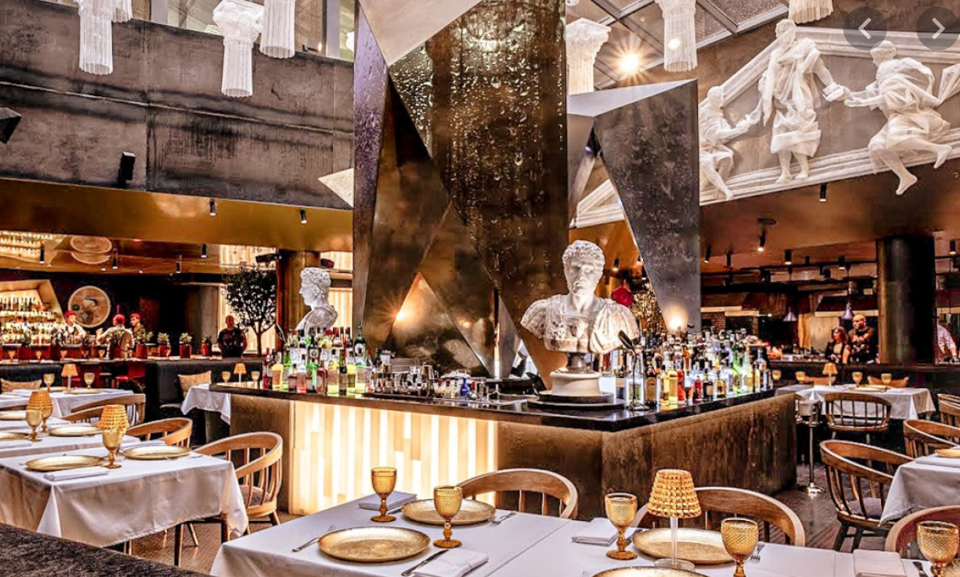

**Introduction**

Family friends are looking to emigrate from Greece to open a restaurant in New York; so what are the current trends and locations of existing Greek restaurants and where may be a suitable location to establish a new venue?

**Background:**

As part of this group-owned enterprise there are currently two highly popular restaurants operating in the major cities Athens and Thessaloniki. The menu is a blend of upmarket modern and traditional Greek cuisine with inspiration from experienced chefs in their employ. The group would like to selectively expand overseas and are confident that through good food and smart business practices, the restaurant can succeed.

The group has chosen New York as a location to conduct research before committing. The city boasts a population of over 8 million people (<https://en.wikipedia.org/wiki/New_York_City>) with one of the most multi cultural cities on earth. Although those identifying with Greek heritage in New York City is small with slightly less than 1% <https://unreachednewyork.com/wp-content/uploads/2012/11/Greek-Profile-Final.pdf> ) there is a strong presence in the neighbourhood of Astoria. This being the case, the reliance on those with Greek heritage would not be the customer base. The restaurant would appeal to 3 to 4-star dining as part of the current operating model.

In addition to expanding the business internationally, our family friends have lead this investigation as they have children & grandchildren in New York and would like to be permanently closer to them whilst managing the American branch and potential future expansions.

**Source Data**

* New York city locations neighborhoods and boroughs, with coordinated will be obtained from the data source: <https://cocl.us/new_york_dataset>
* In order to gather data for existing Greek restaurants, the location platform FourSquare ( <https://foursquare.com/> ) will be accessed and matched with our dataset.

**Processing**

• Data will be collected from <https://cocl.us/new_york_dataset> and cleaned and processed into a dataframe focussing on Greek restaurants in the 5 boroughs.

• The location platform FourSquare is used to locate and filter Greek restaurant venues. The ratings, tips, and likes by Foursquare users are matched and added to the dataframe.

• Data is filtered to determine venue trends and how different neighbourhoods compare.

The final summary and recommendations will be made once the data has been processed.